Introduction to Common Planet

Common Planet is a proposed re-imagining of the control, use, and access to all the land, buildings, houses, and resources on the planet. And features a reward (or credit) system based on Flow Credit currency, a form of non-physical object money.
Launched in 2015, the proposal was previously referred to as EarthVote across their social media channels acting as a research project and launchpad for their concepts before rebranding to Common Planet with a new website launch in 2018.
Older videos for the proposal are still accessible from the EarthVote YouTube channel here.

How it works
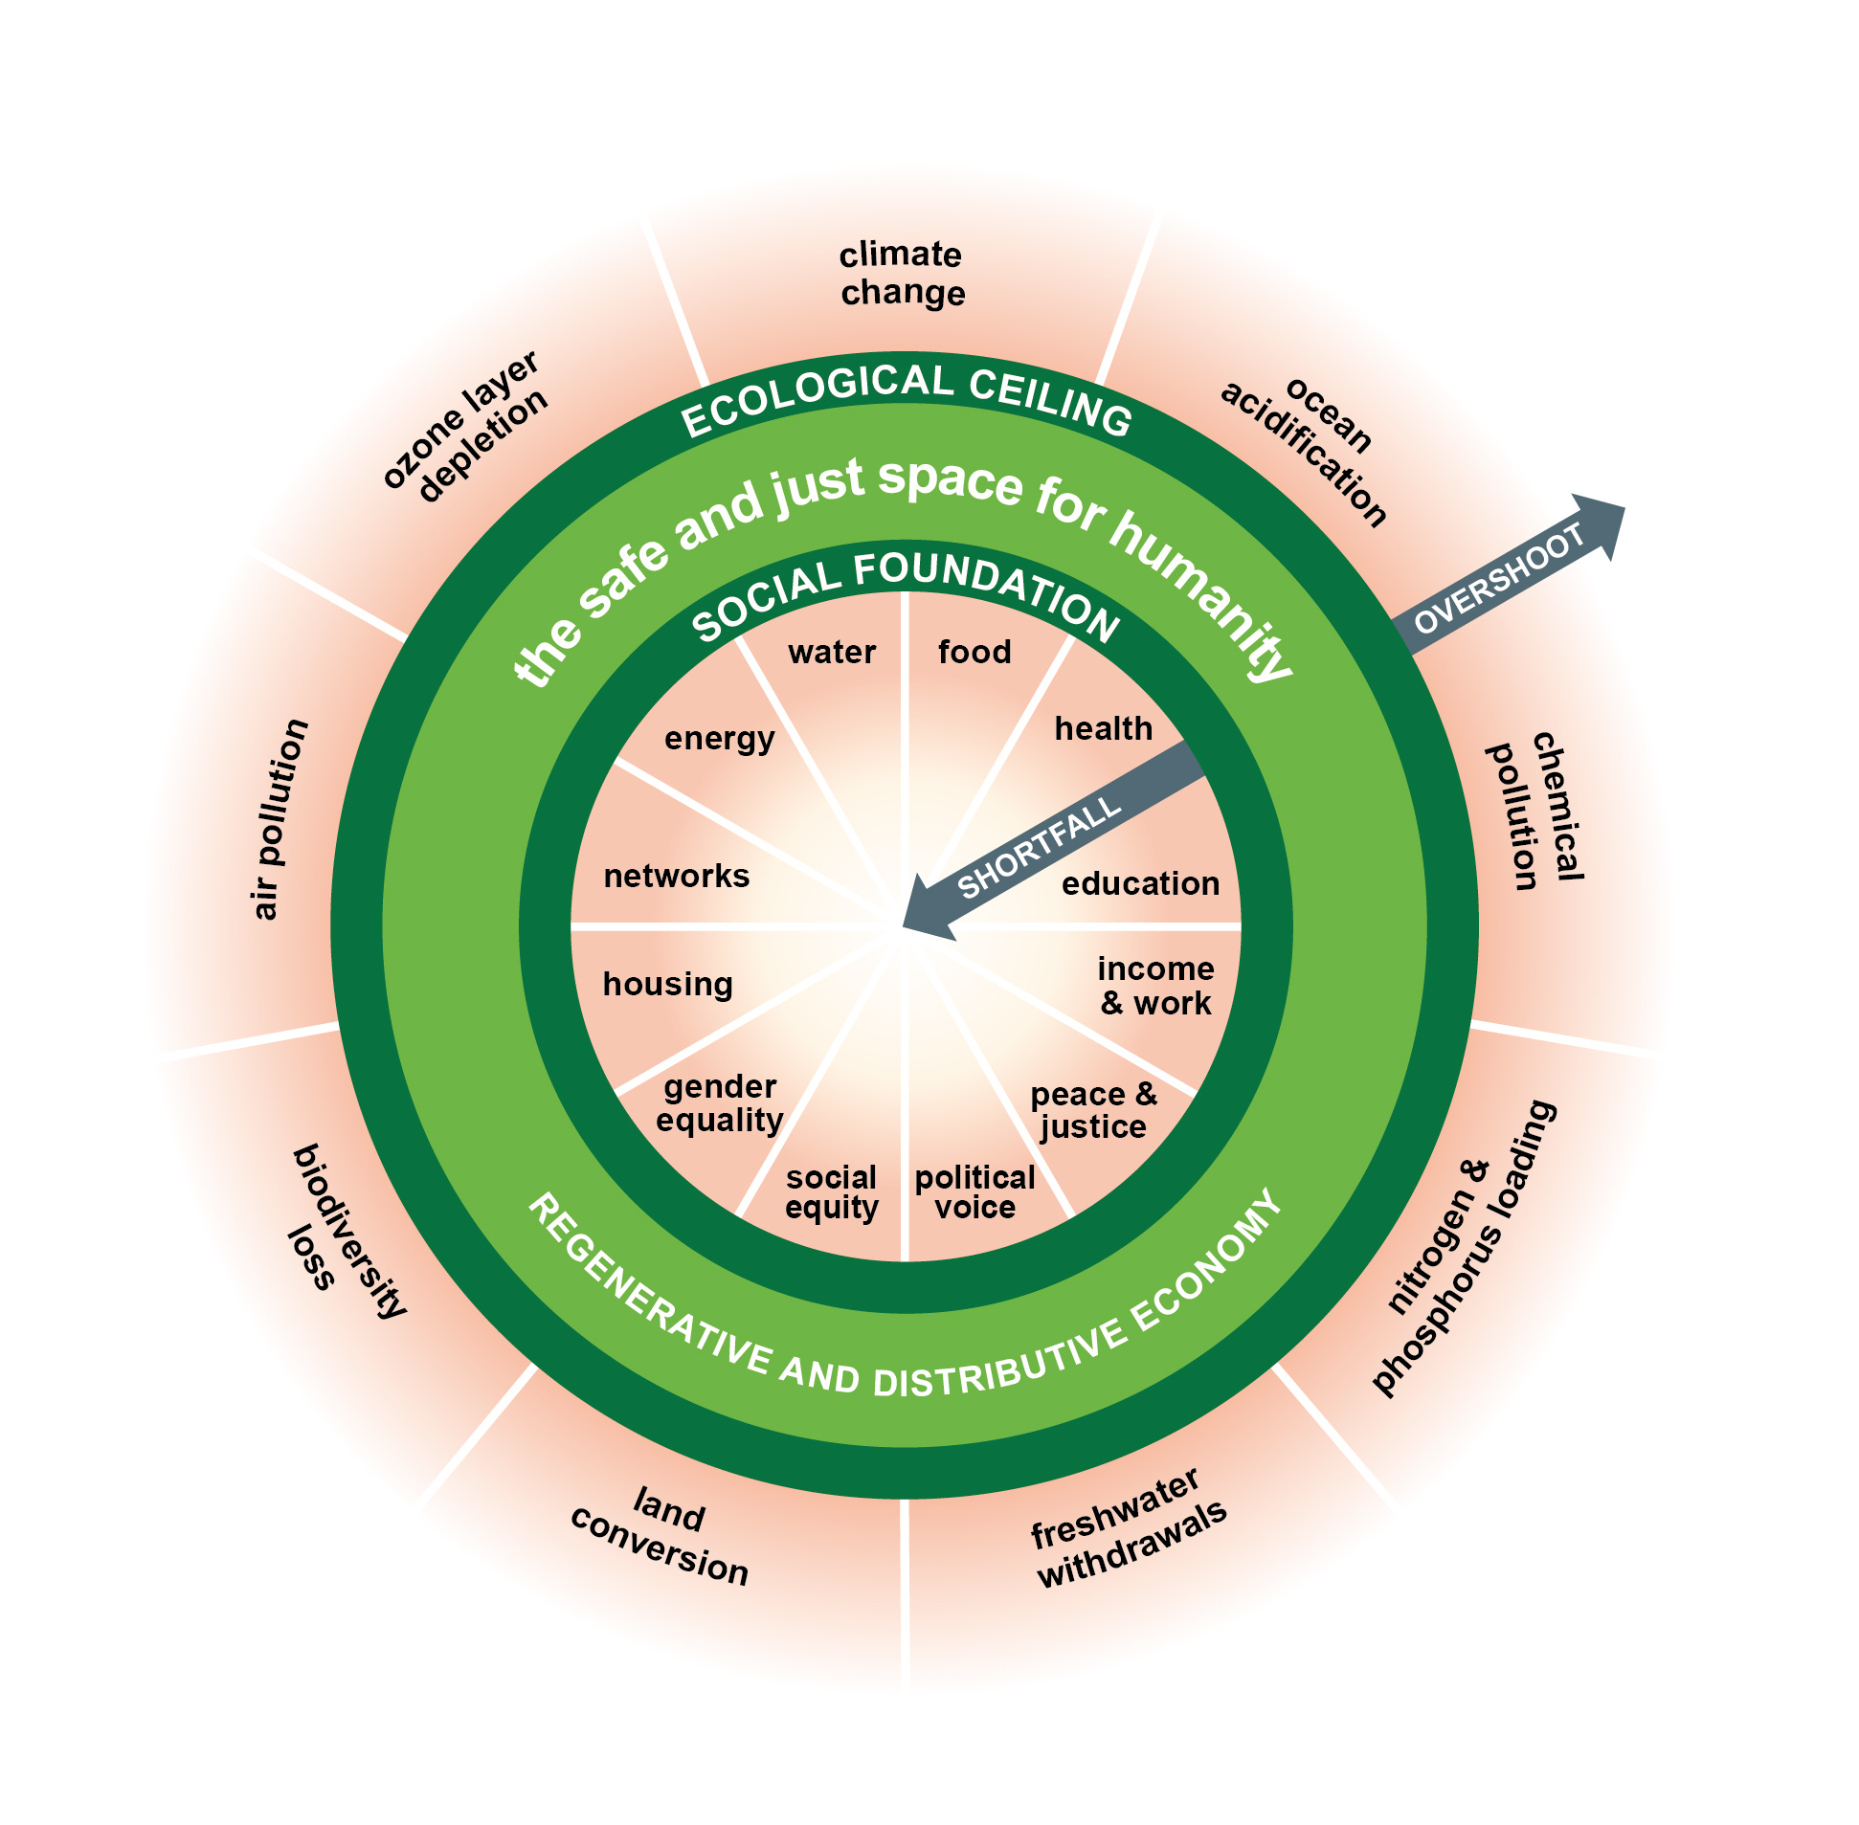
Common Planet uses a combination of Doughnut Economics and its reward credit system to determine resource boundary and extraction methods. The credit is used to allocate resources based on the doughnut's boundaries to determine where resource extraction should or shouldn't be. Credit is then earned if the methods used are determined not to surpass the ecological ceiling creating an overshoot, nor a shortfall to the social foundation.

Proposal highlights
- All debts released
- Unconditional income
- Non-transferable reward system reducing theft and crime
- Maintains a property system
- All debt-based monies converted to its reward system
- Interest, tax, and inflation free

Links
Website: https://common-planet.org
Facebook: https://www.facebook.com/CommonPlanetOrg
Twitter: https://twitter.com/Common_Planet
YouTube: https://www.youtube.com/channel/UC3hE3JvmD9tFdEyUM_IC0Iw

Powered by ezWeb.ie

